**Practical Exercise - Walkthrough**

**First create a While loop that the entire automation will be contained in. This will make sure all sheets are indexed through until the end.**

* Find and add a **While**activity to the main container
* Create an int32 variable called **Index**

              o       Set its default value to 1

* Create an int32 variable called **N**

              o       Set its default value to 3 (it can be changed depending on the number of sheets)

* In the properties of the **While**activity:

              o       In the condition parameter, write: index <= N

                            ▪        This makes sure that as long as the index is less than what **N**is set to, the automation will keep aggregating sheets

* This is what it should look like:

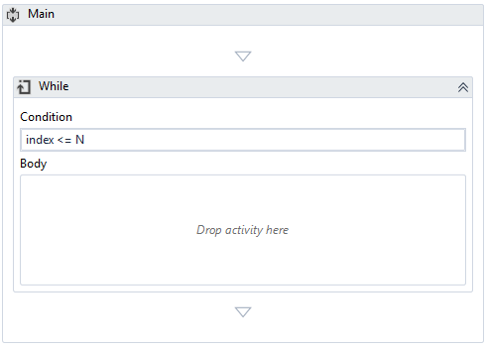

Next, activities need to be added that will read the sheet in each iteration and add them to the main sheet.

* Find and add a **Read Range**activity into the body of the **While**activity

o       Set the workbook path to the full path of the sample Excel workbook (downloaded in the outline - previous material)

o       Set the sheet name to: “Sheet” + index.ToString

▪        This assumes the workbook sheets will be named Sheet1, Sheet2, …, etc.

o       In the output parameter, use the Ctrl-K shortcut to create a DataTable called **partialTable**

If we want the consolidated sheet to have the data from all the sheets, means we have to treat the addition of the first sheet data separately, to add the whole tale, together with the headers. The other sheets data only has to be appended at the end, without adding column headers

* Find and add an **If** activity below the **Read Range**activity

               o       Set the condition parameter to: Index = 1

* Find and add a **Write Range**activity to the ‘Then’ branch of the **If**activity

               o       Set the workbook path to “**Consolidated**.**xlsx**” - this will create a new workbook with the respective name in the project folder, if it doesn’t already exist.

               o       Set the DataTable input to **partialTable**

               o       This branch of the **If**will create a workbook with the first sheet as a base

* Find and add an **Append Range**activity to the ‘Else’ branch of the **If**activity

               o       Set the workbook path and DataTable input to the same values as the **Write Range**activity

               o       This will append the ranged that is read from each of the next sheets to **Consolidated**.**xlsx**

* Finally, add an **Assign**activity below the **If**activity

               o       Assign **index + 1**to **index**

               o       This will increment the loop counter so the sheets will progress from 1 to 2 to 3 and so on…

* This is what the workflow should look like inside the body of the **While** activity:

